Evaluation: Random Forest
Accuracy: 0.966
Precision: 0.9659486065458459
Recall: 0.966
F1 Score: 0.9659318418233109
Jaccard Index: 0.934992444362737
Matthews CorrCoef: 0.9575208741825881
Cohen’s Kappa: 0.9575
Specificity: 0.9915
AUC: 0.998161
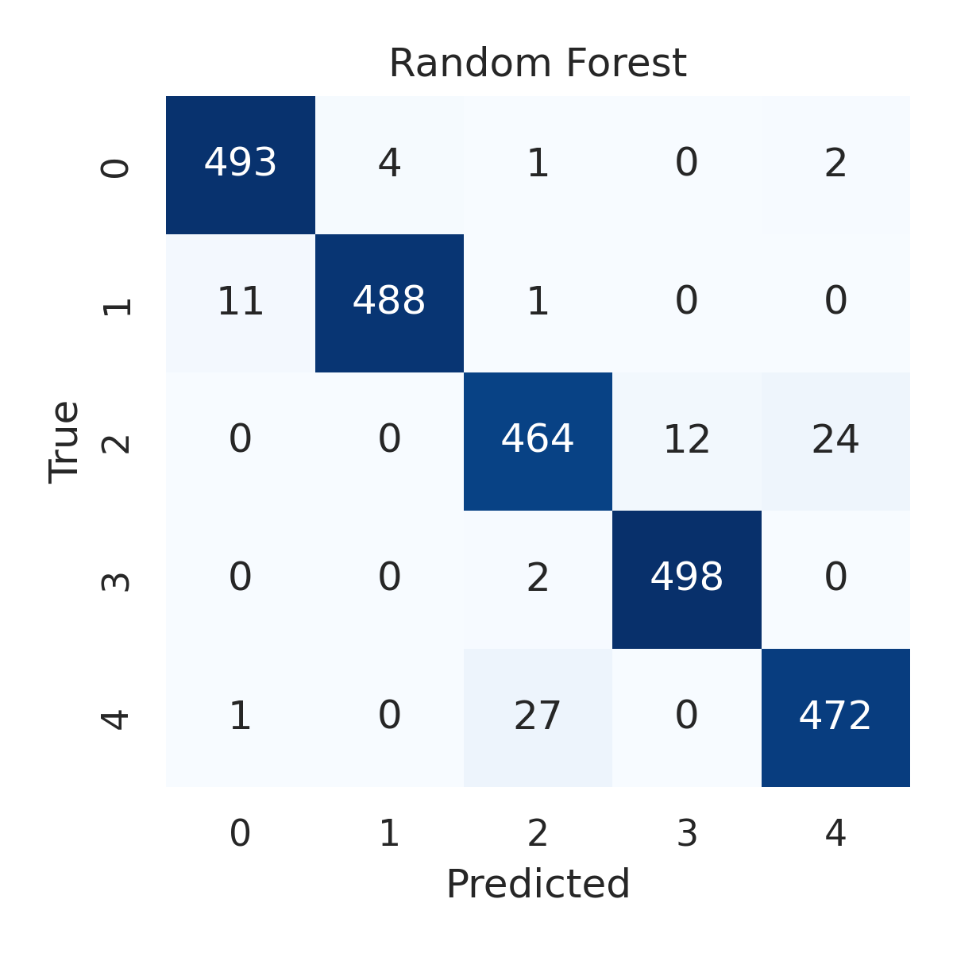

Combined ROC Curves
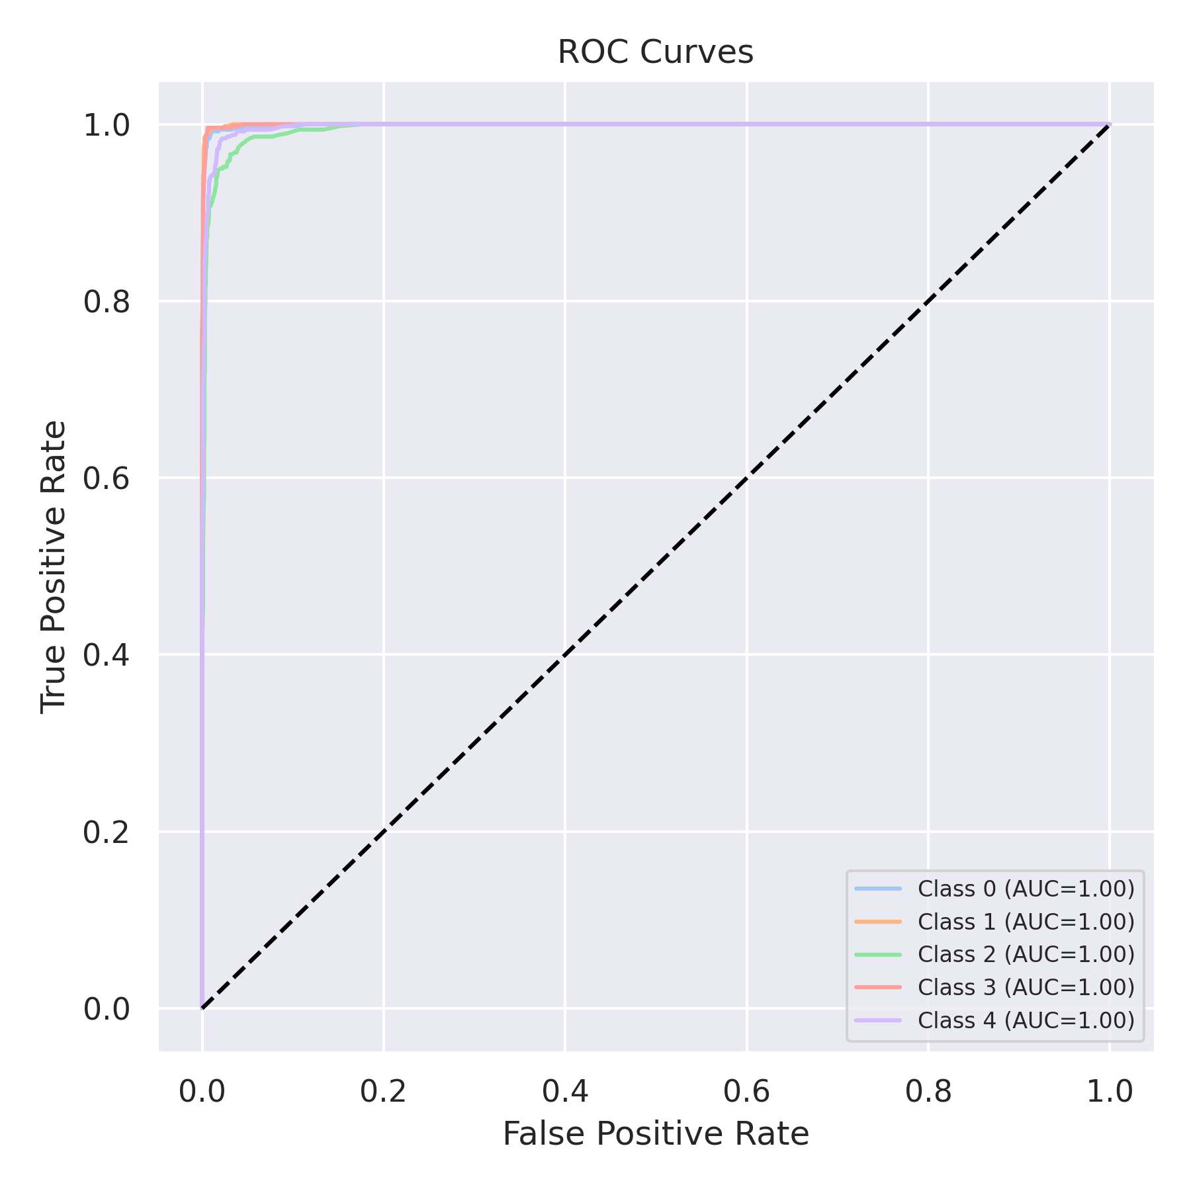

Evaluation: K-Nearest Neighbors
Accuracy: 0.8892
Precision: 0.8915503797607013
Recall: 0.8892
F1 Score: 0.8884207979467057
Jaccard Index: 0.8009378660796694
Matthews CorrCoef: 0.862414298843487
Cohen’s Kappa: 0.8614999999999999
Specificity: 0.9723
AUC: 0.979777
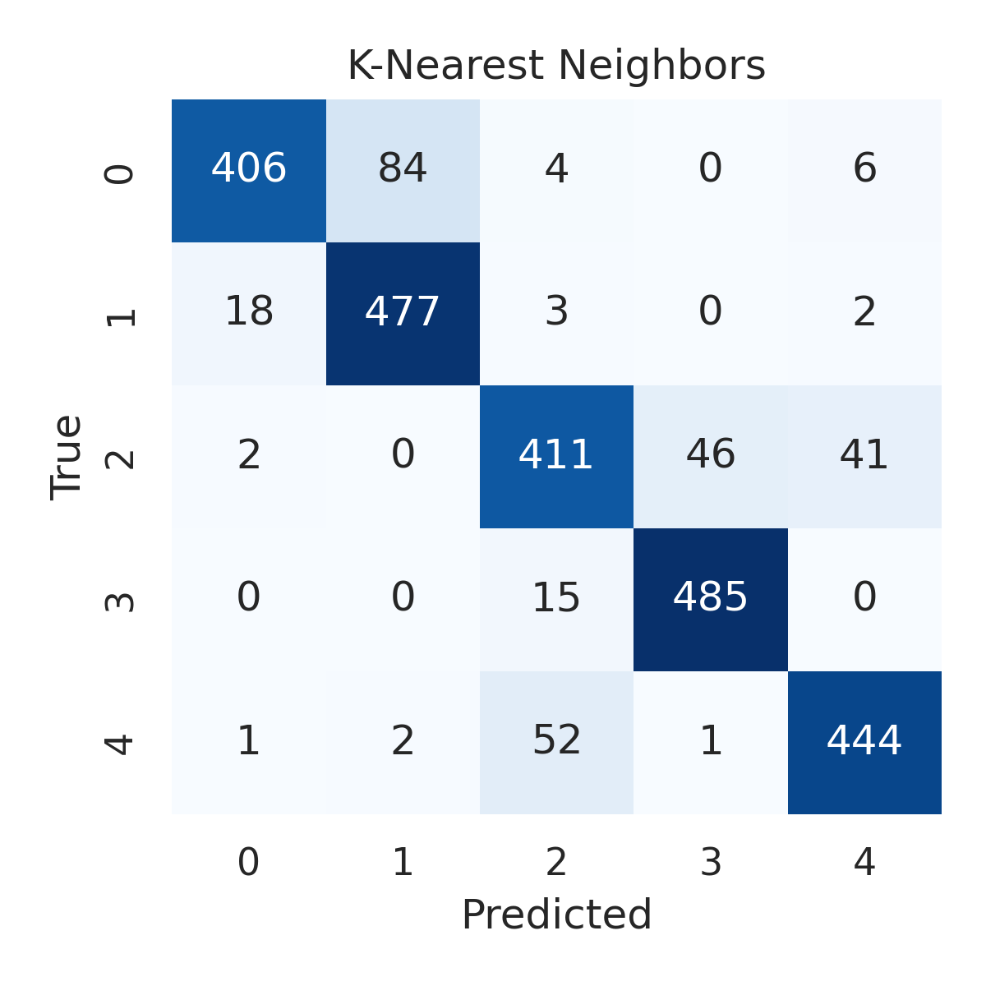

Combined ROC Curves
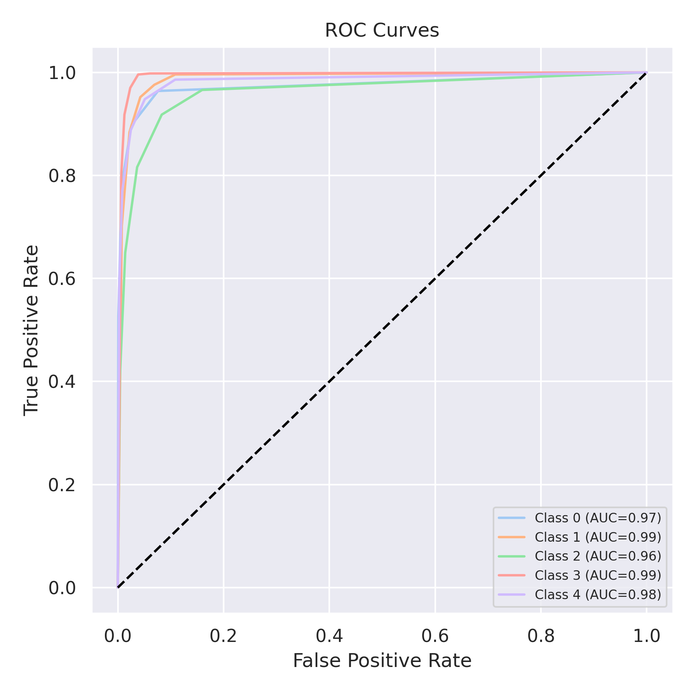

Evaluation: Decision Tree
Accuracy: 0.9472
Precision: 0.9475369952138957
Recall: 0.9472
F1 Score: 0.9473286907065561
Jaccard Index: 0.9013914555382091
Matthews CorrCoef: 0.9340196146178625
Cohen’s Kappa: 0.9339999999999999
Specificity: 0.9868
AUC: 0.967
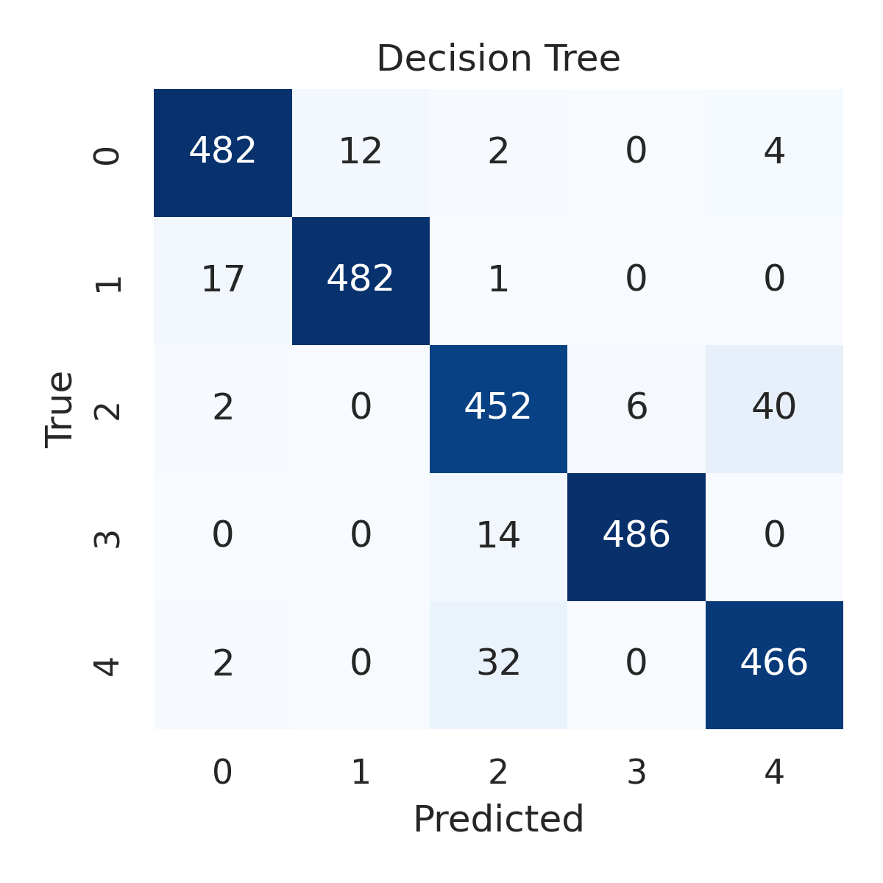

Combined ROC Curves
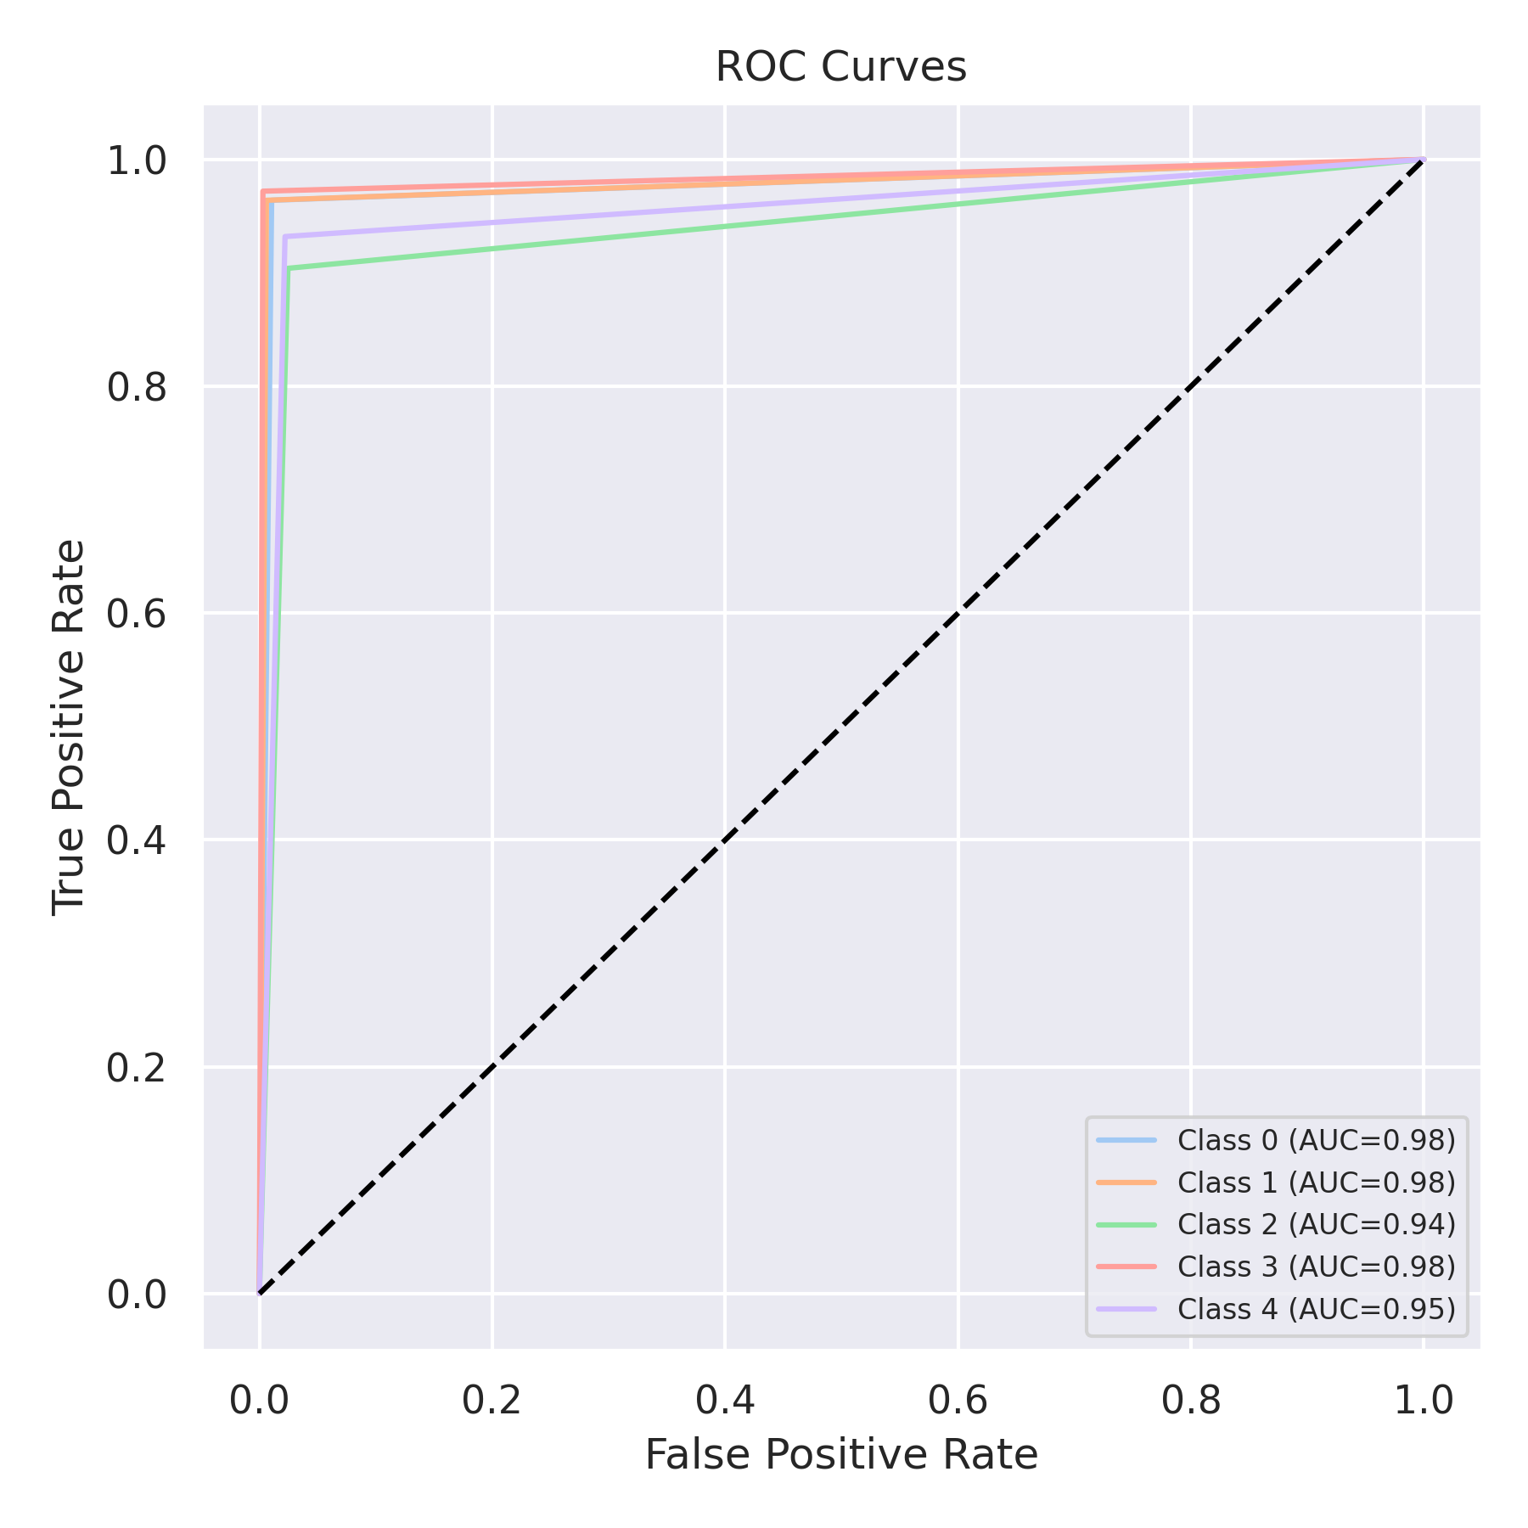

Evaluation: Extra Trees
Accuracy: 0.9712
Precision: 0.9711558925732341
Recall: 0.9712
F1 Score: 0.9711536030983323
Jaccard Index: 0.9445847183590184
Matthews CorrCoef: 0.9640121466295717
Cohen’s Kappa: 0.964
Specificity: 0.9928000000000001
AUC: 0.998795
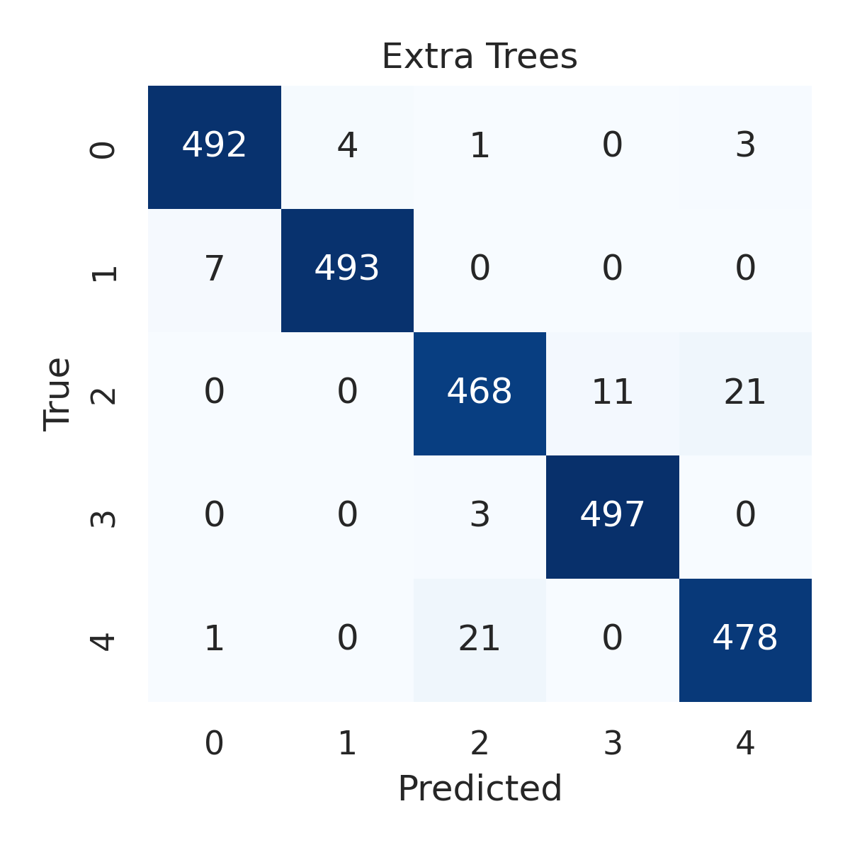

Combined ROC Curves
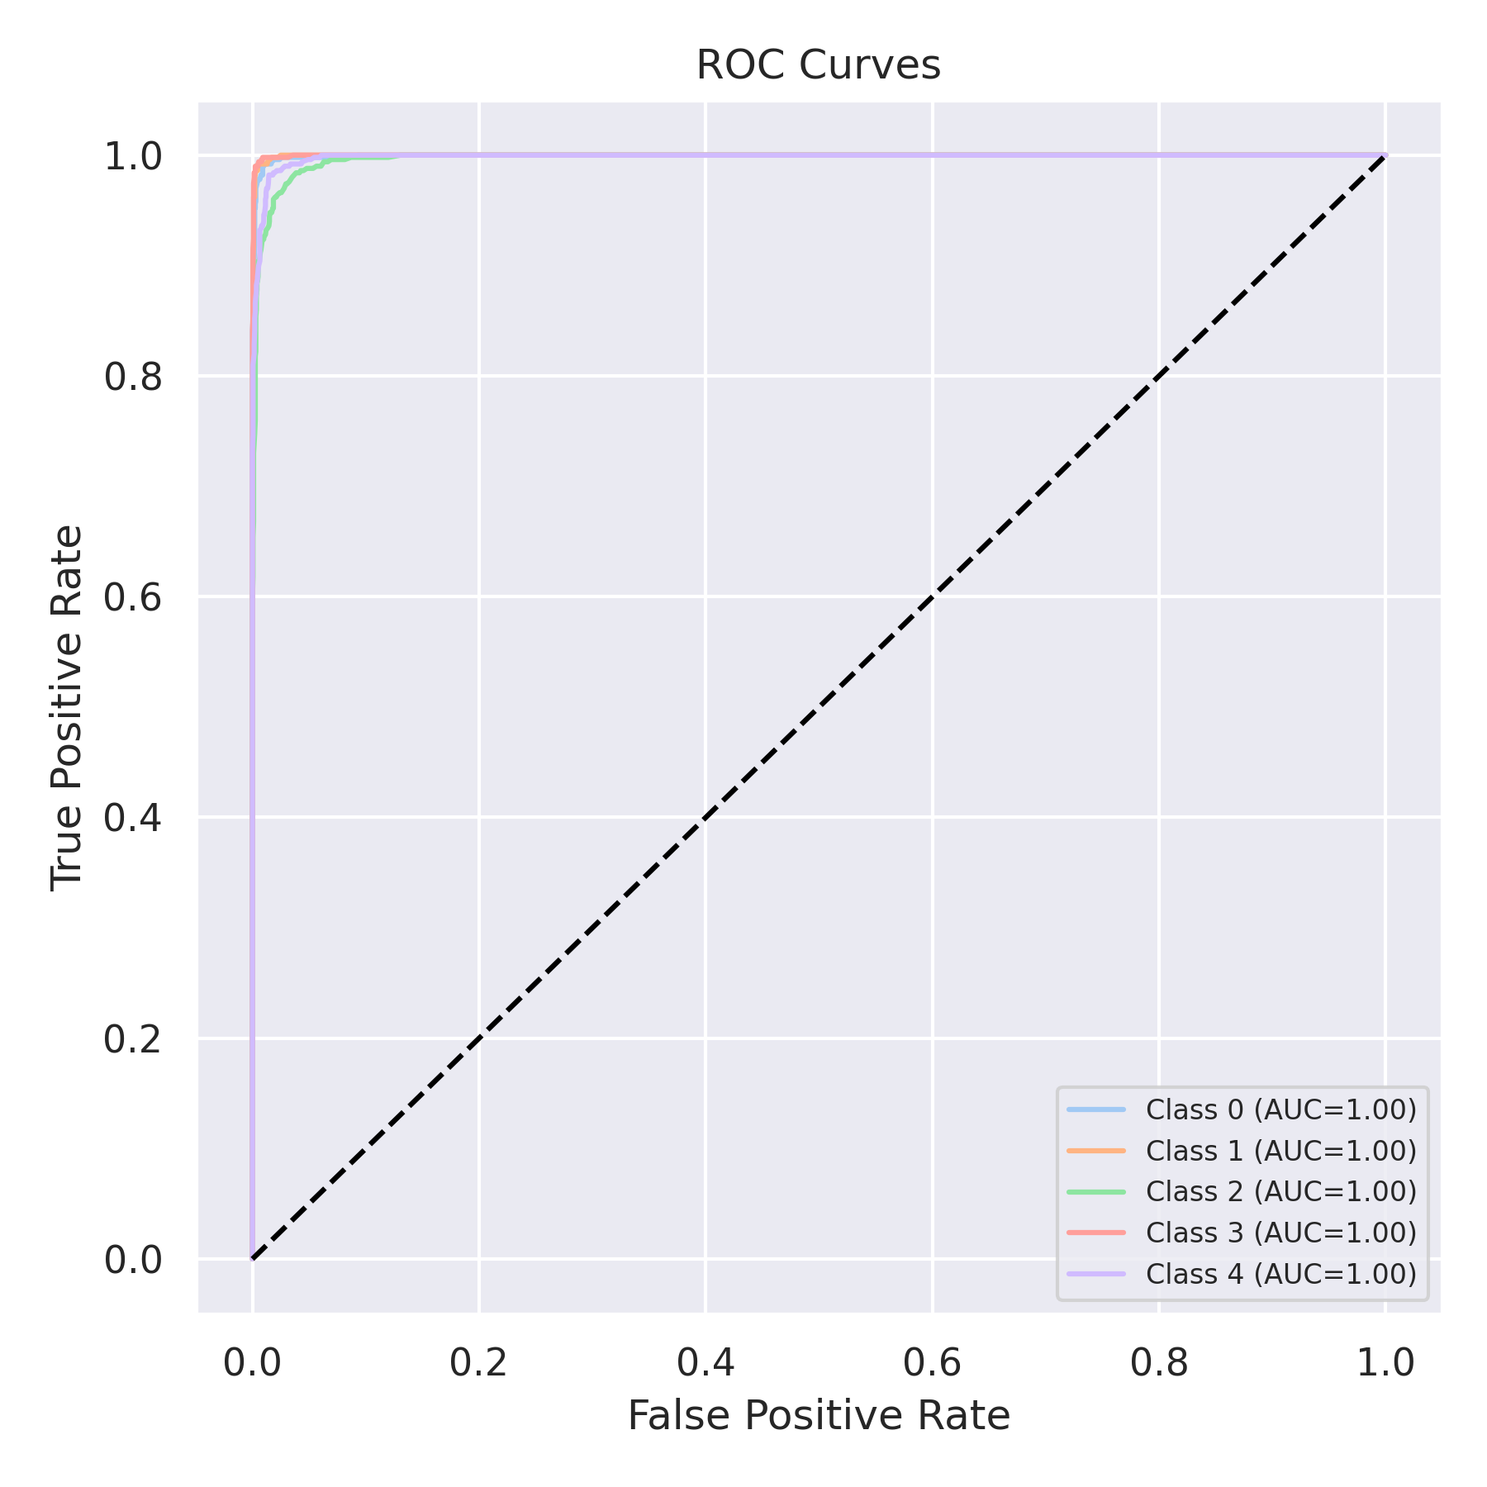

Evaluation: Bagging Classifier
Accuracy: 0.9684
Precision: 0.9688336370278772
Recall: 0.9684
F1 Score: 0.9684387670823656
Jaccard Index: 0.9395745686590168
Matthews CorrCoef: 0.9605901075783344
Cohen’s Kappa: 0.9605
Specificity: 0.9921000000000001
AUC: 0.9962445000000001
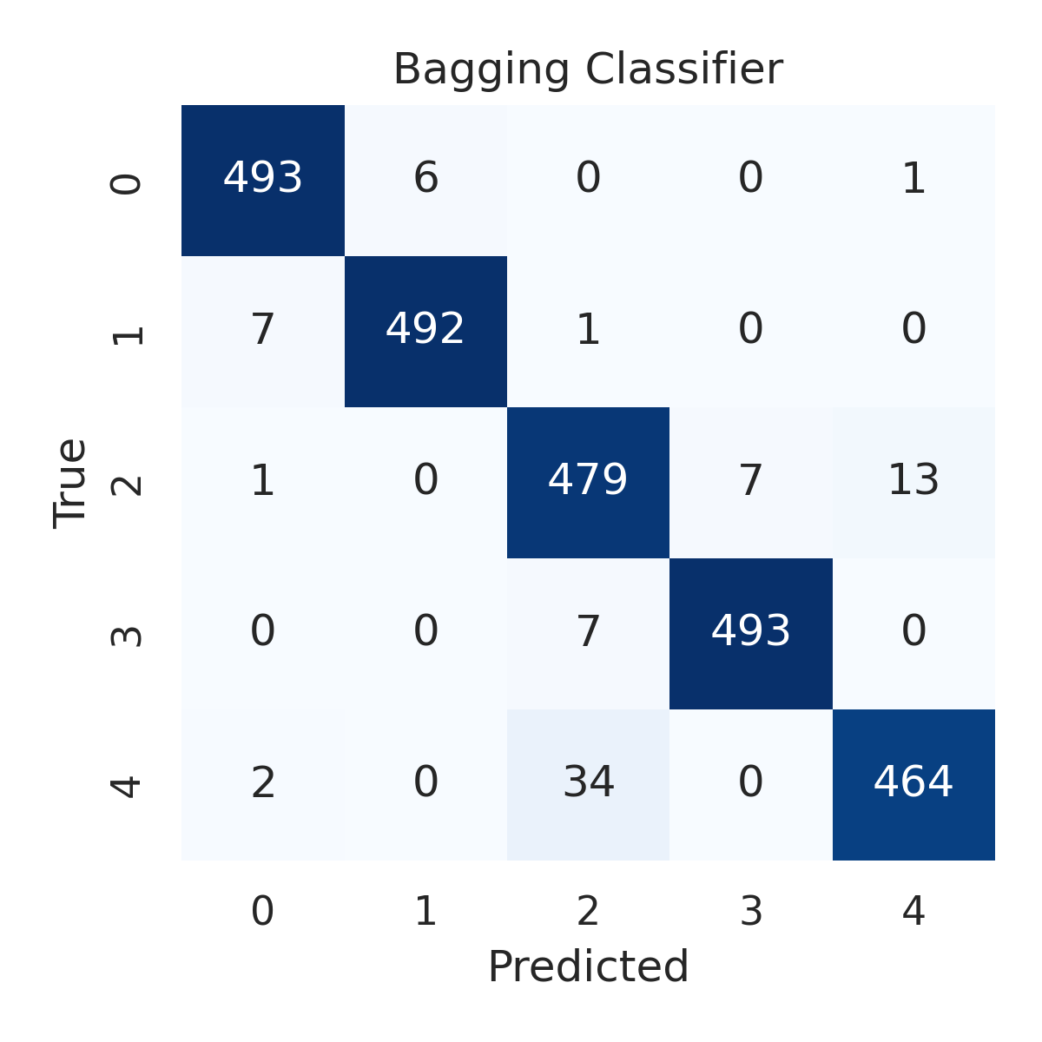

Combined ROC Curves
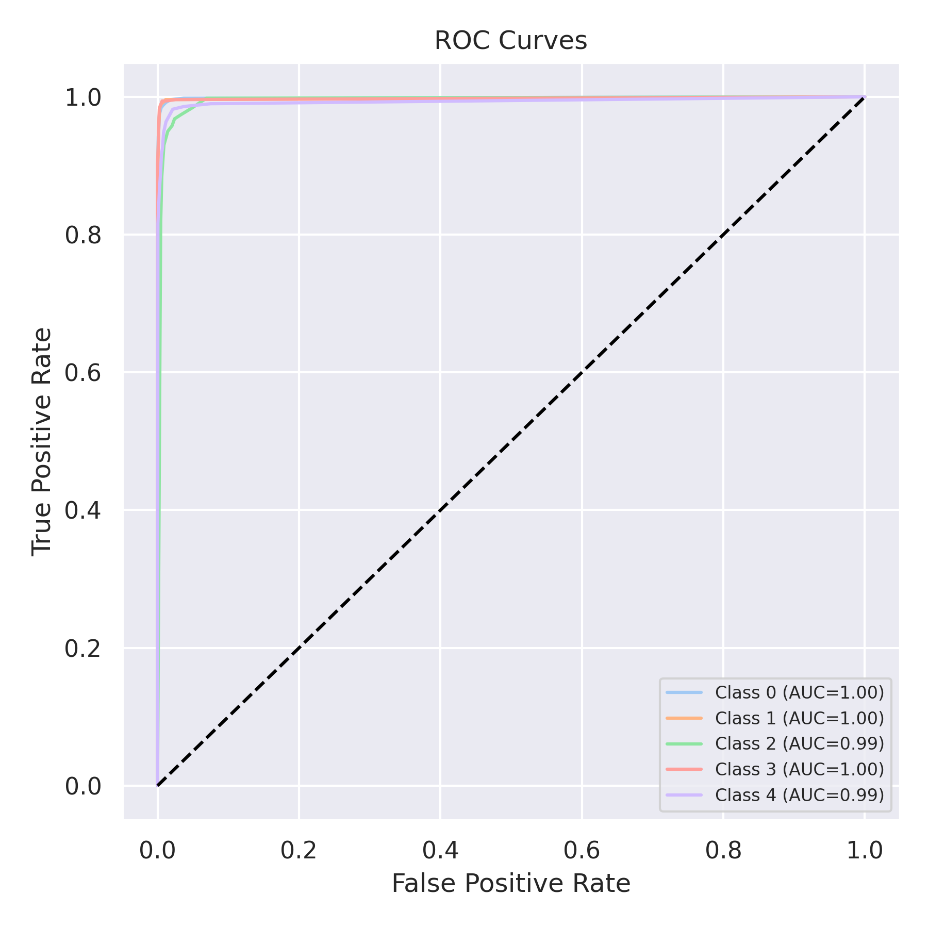

Evaluation: XGBoost
Accuracy: 0.9796
Precision: 0.9795808702659706
Recall: 0.9796
F1 Score: 0.979582600041667
Jaccard Index: 0.9603392595479067
Matthews CorrCoef: 0.9745038980233882
Cohen’s Kappa: 0.9745
Specificity: 0.9949
AUC: 0.9993934000000001
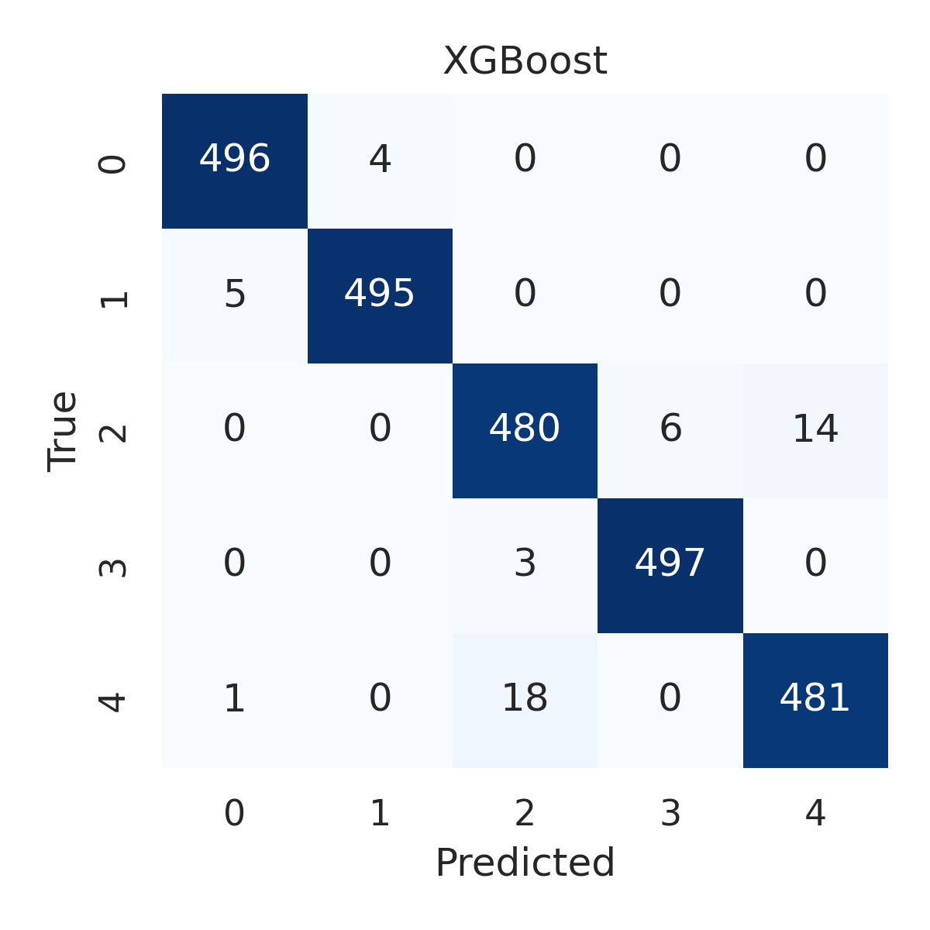

Combined ROC Curves
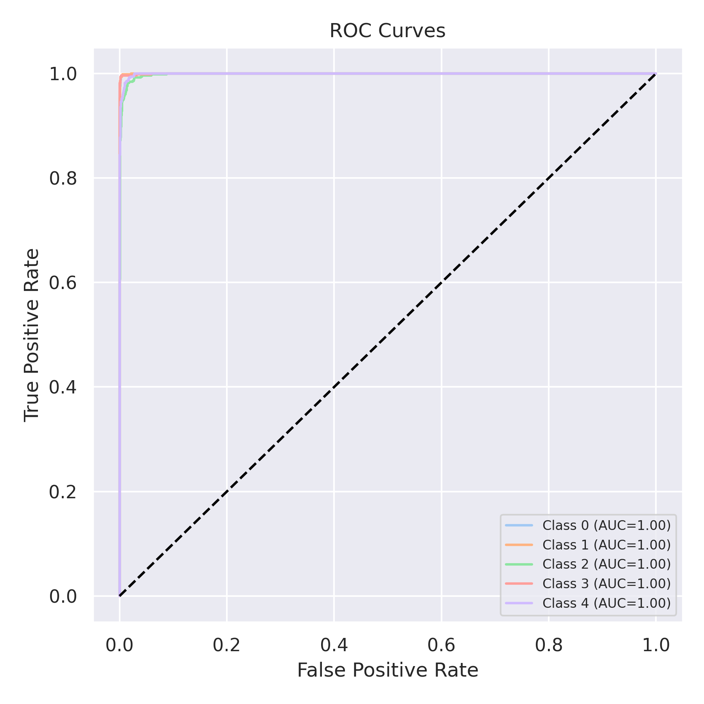

Evaluation: LightGBM
Accuracy: 0.982
Precision: 0.9820014422397911
Recall: 0.982
F1 Score: 0.9819893321712645
Jaccard Index: 0.9649198601228991
Matthews CorrCoef: 0.977505669549325
Cohen’s Kappa: 0.9775
Specificity: 0.9955000000000002
AUC: 0.9993956
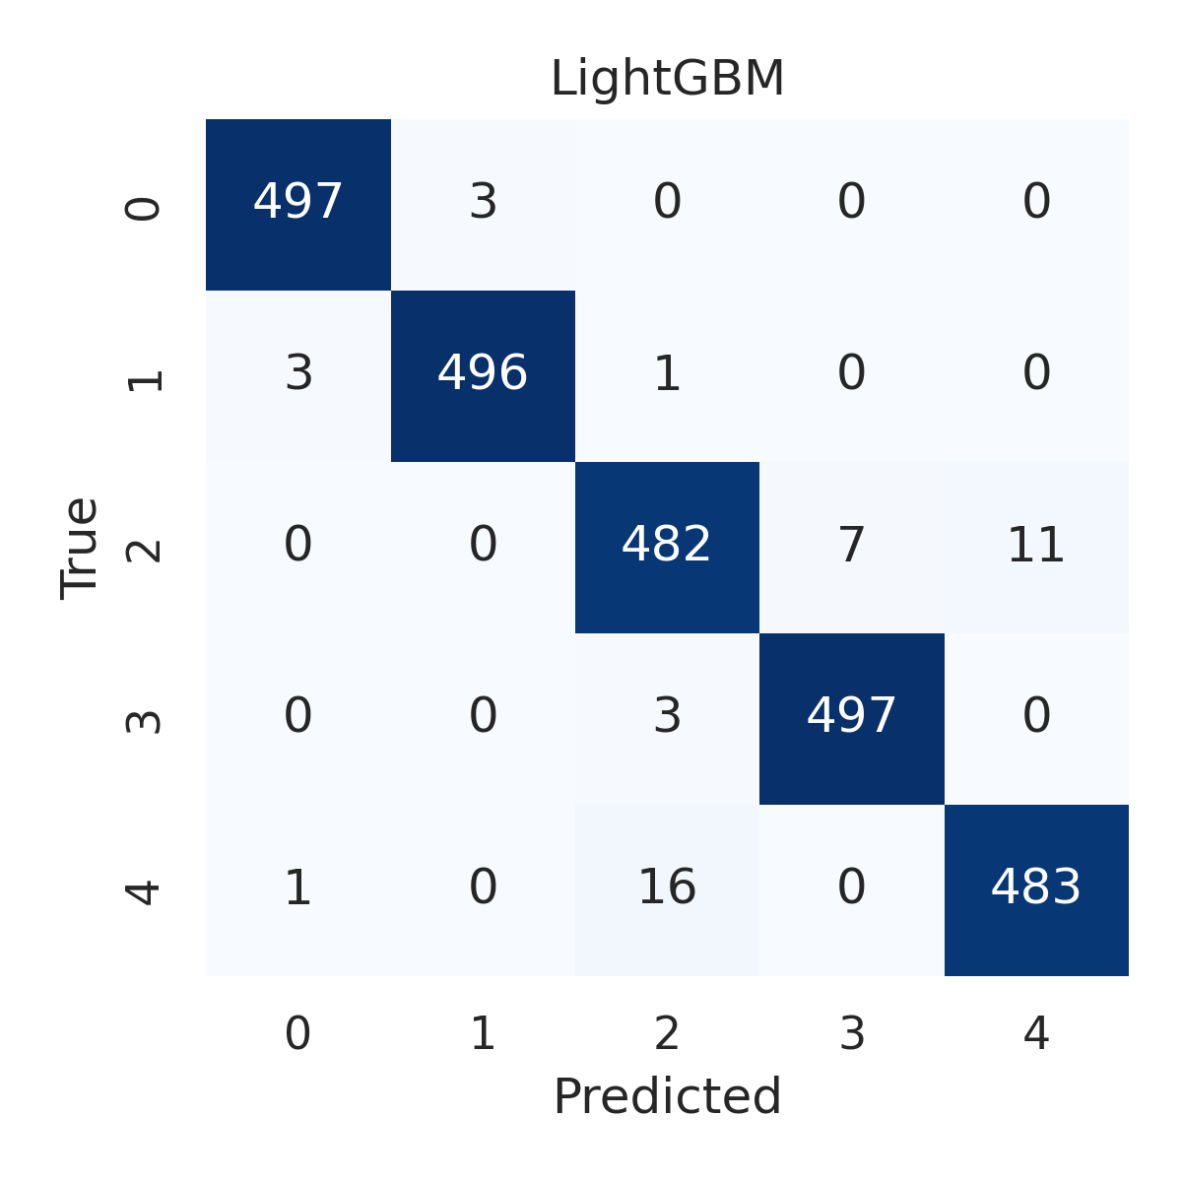

Combined ROC Curves
